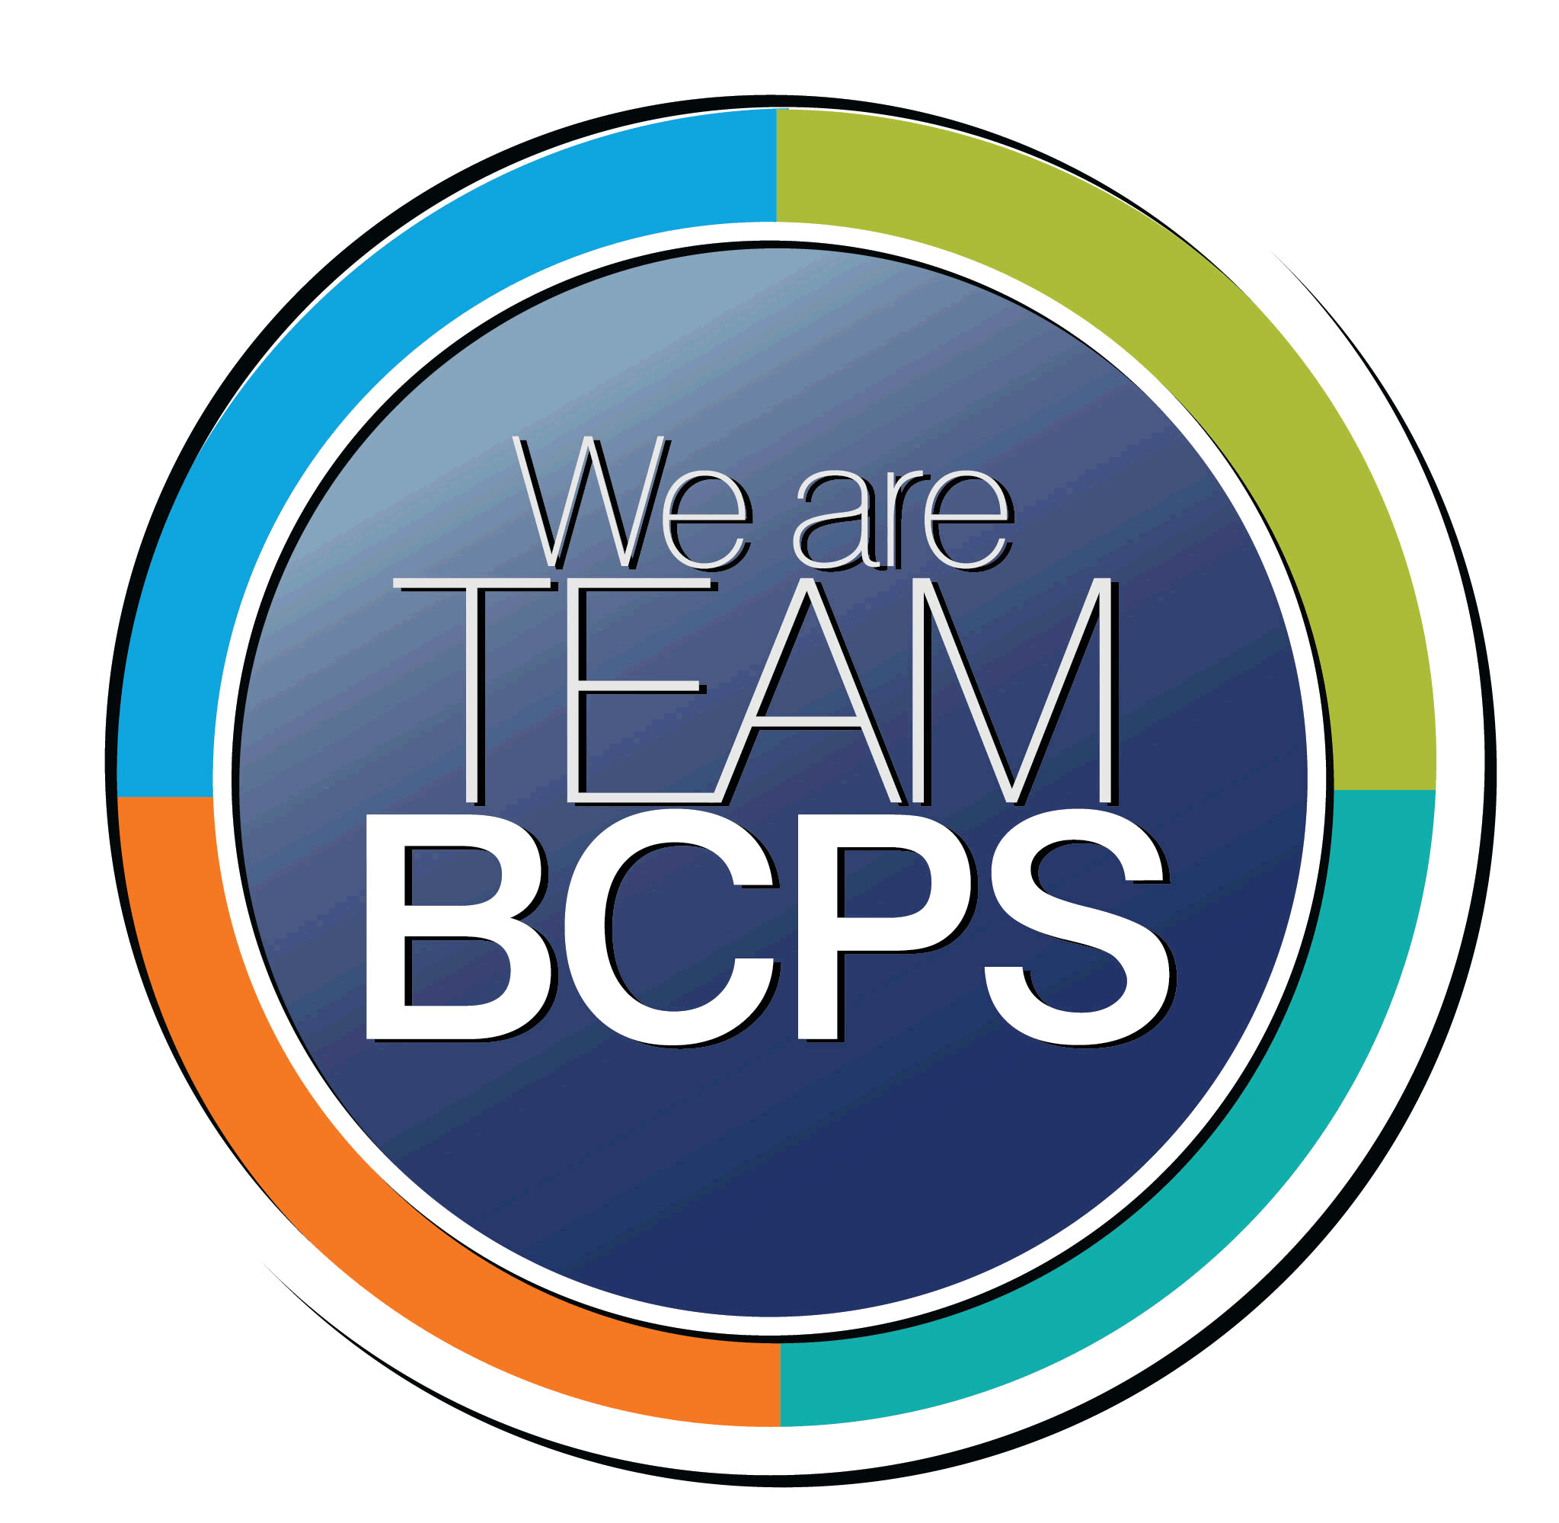 Schoolwide Positive Behavior Plan
Baltimore County Public Schools

Date Completed: 7/29/2022 School Year 2022-2023
School: Glenmar Elementary School

Section 1: Initial Steps
School Climate Team
Identify members of a School Climate Team (consider a representative selection of members). The team meets initially to examine equity concerns and data and to develop the Schoolwide Positive Behavior Plan. The team should then meet monthly (minimum quarterly) to assess the effectiveness of the SWPBP on an ongoing basis.
The school has identified a School Climate Team which is composed of two administrators, primary and secondary teachers, and student support services staff (school psychologist, school social worker, school counselor). The team will meet monthly to discuss implementation of interventions, monitor the effectiveness of the interventions, and suggest changes or modifications to those interventions.

Equity Lens
Through an equity lens, identify what the data indicate about the social-emotional needs of students and the support provided by staff members relative to disproportionality between student groups, especially for African Americans or students receiving special education. Also consider the school’s population with regard to ELL, Latinx, and/or other student groups. (Information may be from School Data Story)
The Glenmar Elementary School Data Story from 2021-2022 reflects the following school demographics: The Kindergarten through Grade 5 2021-2022 September 30th enrollment indicates that we have 284 students, and our demographics are as follows: 65.1% Black/African American, 9.1% White, 13.7% Hispanic, 3.8% Two or More Races, 6.6% Asian. The proportion of students eligible for receipt of special services are as follows: 10.5% English Learner, 48% Free and Reduced Meals, and 21.4% Special Education. The overall enrollment count has increased from 2020-2021 school year. During the same time period, the number of Black/African American, Hispanic/Latino, and Two or More Races student and student who receive Special Education services has increased while the number of Asian and White students and student who receive Free and Reduced Meals has decreased.

The 2021-2022 Stakeholder survey results:
The 2021-2022 Stakeholder Survey domain values were 79.4 for Academic Aspirations, 62.6 for Belonging, and 71.8 for Student Support.
The 2021-2022 Academic Aspirations domain results indicate the most favorable results for the White student group. In contrast, the Hispanic student group reported the highest as unfavorable among racial groups.
The 2021-2022 Belonging domain results indicate the most favorable results for the White student group. In contrast, the Black/African American student group reported the highest as unfavorable among racial groups.
The 2021-2022 Student Support domain results indicate the most favorable results for the White student group. In contrast, the Black/African American student group reported the highest as unfavorable among racial groups.

Data Analysis
Summarize what the data tell about the school climate. (Information from School Data Story)
The data indicates belonging and student support are areas that need improvement to be equitable. Specifically, our Black/African American student group reported the highest unfavorable in the area of belonging, this is consistent when looking at other academic data (MCAP and students in Special Education). This indicates we as a school need to work to be inclusive and provide a safe and supportive environment for our students.

Climate Goals
Identify the school’s goals in improving the social-emotional climate of the building. (Information from School Progress Plan)
Educators will examine and interrogate their personal biases to become aware of the ways in which their own cultural experiences influence the conditional and learning opportunities that they create for students.

Teachers will create and sustain a safe, welcoming, and supportive classroom environment which values inclusivity and diversity.

Section 2: Developing and Teaching Expectations
Expectations Defined
Identify a School Code of Conduct with 3-5 positively stated school expectations. Develop a way to communicate the identified rules, based on the schoolwide expectations, for specific settings within the school building. Expectations should be clearly stated, communicated, taught, and frequently referenced.
I am Caring. I am Helpful. I am Organized. I am Mindful. I am Prepared. (Glenmar Gators CHOMP)

Schoolwide expectations will be communicated consistently throughout the building, in each classroom, hallways, cafeteria, and morning announcements. A presentation will be made to staff on the first day of school explaining to teachers how to communicate, model and teach, and reinforce the schoolwide expectations in their classroom and around the building. In addition, signs with specific examples of the school wide expectations will be posted throughout the building.

Classroom Plan for Teaching and Reinforcing Expectations, Routines, and Procedures
Teachers develop visuals to communicate culturally relevant classroom expectations, routines, and procedures based upon the schoolwide expectations. Educators explicitly teach expectations, routines, and procedures. The school staff recognize and reinforce expected and positive behavior. Teachers identify encouraging procedures and corrective procedures for their classrooms.
Teachers will be provided with professional development during the Back-to-School week on how to develop, establish, and communicate the school wide expectations in their classrooms. Teachers will establish routines and expectations with their classes/grade levels during the first few weeks of school, visuals will also be provided to support this work. Additionally, teachers will be provided with professional development on Conscious Discipline in the first month of school. Teachers will be able to recognize and celebrate their student’s success by submitting positive behavior referrals.

Family/Community Engagement
Identify how the Schoolwide Positive Behavior Plan, the schoolwide expectations, and/or interventions will be communicated and shared with families. Consider how to include family and student voice in the initial plan and in evaluating the plan throughout the year.
The schoolwide expectations will be communicated with parents in the Monthly Newsletter, with activities that can be done at home to reinforce our expectations. During Back-to-School Night teachers will be provided with consistent slides to include in their presentations to share the expectations with families. The schoolwide expectations will be placed on the school website. The School Climate Committee will identify options to obtain student and parent/guardian voice throughout the school year.

Section 3: Developing Interventions and Supporting Students
Resource Mapping of MTSS
Identify the evidence-based practices and interventions offered at Tier 1, Tier 2, and Tier 3 to support all students. Consider what culturally responsive interventions the school requires to meet the specific needs of the students.
Tier 1:
- Conscious Discipline
  - Greeting – options listed at the door
  - Morning Meeting with engaging and thoughtful prompts (unite, connect, disengage stress, commit, connect)
  - Safe Place with visual reminders for students
  - Commitments referenced throughout the day
- Restorative Practices
  - Noticing Statements, Affective Statements, Affective Questions
  - Restorative circles and meetings to repair harm
  - Schoolwide morning meetings once a month
- Engaging morning work, music, activity while they eat breakfast
- Class-wide incentives
- Proximity
- Providing Choices
- Virtues Language posted and utilized throughout the day
- Schoolwide Behavior matrix
- Positive students and family relationships
- Classroom Guidance Curriculum
- Home/School communication
- Gatorrific Referrals/Positive Praise

Tier 2:
- Check in/Check out
- Mentoring
- Small group SEL support
- Gator Pass/Break Card
- Scheduled Breaks
- Behavior Chart
- Buddy classroom

Tier 3:
- Individual Counseling
- Social work services
- Administrative Actions
- Behavior Intervention Plan
- Referral to outside provider
- Wrap around supports
- Parent-focused assistance
- Individual Earning; Extremely specific plan

Social-Emotional Learning
Identify the specific evidence-based social-emotional learning skill development practices the school will implement during the school year. Consider the importance of trauma-informed care, mental health awareness, level of students’ coping skills, etc. Determine how the social-emotional learning and the SEL competencies will be integrated into the school’s programming. Consider the need for any training the staff members may require.
The school will use Conscious Discipline to encourage and build positive relationships and problem solving. Restorative Practices will be used for specific incidents to support students with problem solving and conflict resolution. The school will also ensure schoolwide expectations are well defined and consistent throughout the school building. The Climate Team will support individual teachers/students who need additional support/scaffolding. Small group instruction will also be available by the counselor, social worker, and school psychologist.

Character Education
Determine how specific evidence-based character education learning will be infused into the school’s programming to promote positive behavior and ethical decision-making. Character education will be culturally responsive and co-created with diverse stakeholders. Consider the need for any training the staff members may require.
Dawn Dehart and the Student Safeties will identify a specific virtue each month which will be related and aligned to the schoolwide expectations. Follow up lessons and activities will support each virtue. Teachers should select a student at the end of each month who exhibited the virtue. These students will be recognized by the Administrative Team.

Professional Development for Staff
Identify the professional development that will be offered to staff members throughout the year in order to support their knowledge, skill development, and implementation of the interventions selected, the character education learning, and social-emotional learning practices. Specify the schedule for professional development and how to obtain teacher feedback during the year to address their concerns and areas in which they want/need more information. (Information from School Progress Plan.)
Classroom Expectations Aligned to Schoolwide Expectations
Conscious Discipline
Review of Tiered Support Model
Collect and analyze data – disaggregate the data, analyze using an equity lens - develop actionable steps based on the data (qualitative and quantitative)
Book Study with Leadership Team

Teacher feedback will be collected using Surveys, PD Feedback tools, and during data discussions. The Climate Team will also establish ways to obtain teacher feedback during the year.

Section 4: Supporting and Responding to Student Behavior
Recognitions/Incentives
Identify a variety of positive consequences, acknowledgements, recognitions, and/or incentives that are linked to the behavioral expectations and rules. Develop a system for implementing the positive acknowledgements consistently in school settings. Consider how to monitor who is being recognized and who is not being recognized and whether explicit or implicit biases may be occurring.
The school will use a variety of positive reinforcements to acknowledge and recognize positive behavioral expectations. Teachers will use a variety of positive reinforcement in their classroom by offering non-tangible rewards (lunch bunches, bring a stuffed animal to school, pajama day). Each class will have a Morning Meeting, teachers will be encouraged to have celebrations and recognition during these meetings. Classes will set goals together and work together to achieve their goals. Teachers can recognize individual students by submitting a positive office referral. Staff members will be encouraged to recognized classes and students throughout the day who are following the schoolwide expectations.

Hierarchy for Behavioral Referrals and Consequences
Identify the behaviors that are teacher-managed, behaviors referred to resource staff, and behaviors referred to administration. Refer to the BCPS Student Handbook for teacher and administrator-led interventions. Consider how unsafe behaviors will be addressed.
Teacher Managed Behaviors:
Behaviors that impact only one student
Behaviors that interfere with others learning
Behaviors that impact orderly learning

Administrator Managed Behaviors:
Behaviors that cause harm or are illegal (Category II and III)

The school’s Climate Team will be available to support teachers with any behaviors upon request or if the data shows us a student needs additional support.
Restorative Conferences
Help establish and create proactive supports (check in/check out, mentor, individual behavior plan)

Response for Intensive Behaviors
Identify a hierarchy of responses to intensive behaviors (i.e., emergency/crisis management/threat assessment/unsafe behaviors) including interventions and supports. Indicate which school staff members will respond as well as procedures and training as needed.
A Team – response team established to respond to support calls
CPI Trained Staff –Brian Dean, Molly Kerrigan, Jonathan Scovitch
Threat Assessment Team – Principal, School Nurse, School Counselor, School Psychologist, School Social Worker

Monitoring the Schoolwide Positive Behavior Plan/Data Analysis
Identify the data that will be collected and reviewed by the School Climate Team in order to identify behavior trends, patterns, action steps, and interventions using a problem-solving strategy. Consider having a uniform referral form for staff to complete to document referrals to administration. Consider how teachers should document classroom-managed concerns/behaviors/difficulties. (Information from School Progress Plan.)
The team will monitor data the Support Forms (referral), positive office referrals, informal observations, Conscious Discipline look-for documents, and student surveys

Section 5: Miscellaneous Content/Components
Click or tap here to enter text.

